**HR Management System**

**Introduction:**

This is an HR management software that aims to automate the management of employees’ records, benefits, and payroll.

Each representation is a distinct area of functionality. The main objective of the HR system is to provide an efficient and user-friendly war for the HR personnel to manage employee data.

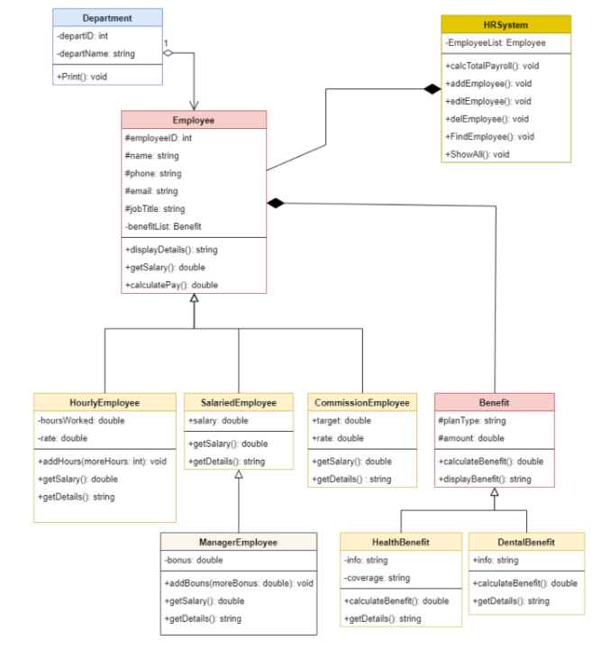

**Implementation of Classes:**

**HRSystem:**

Attributes:

Employee* EmployeeList[35] : an array of Employee’s objects with maximum 35 object

String hrName : to store the name of the HR personnel

Double totalPayroll : to store the total Payroll

Static int countEmplyees : to store the current number of the employees

Methods:

clearScreen(); // to clear the screen after a specific operation

getOption(); // to display the available option for the HR personnel ( add a new employee , display all employees , edit employee , delete employee , display payroll )

the option functions:

addEmployees();

CalcTotalPayroll();

ShowAll(); // to display all employees with all details

editEmployee();

deleteEmployee();

findEmployeee();

**Employee:**

* Is the parent class for all employee’s classes

Attributes:

String name;

String phone;

String email;

String jobTitle;

Double salary;

Int employeeID;

Methods:

setDetails(); // make the user enter the data of the employee

getDetails();

getSalary(); // return the salary in double type

calculatePay( double salary );

**HourlyEmployee:**

Attributes:

Double hoursWork; // weekly hours

Double rate; // $/hr

Methods;

addHours( double morehours );

getSalary(); // to return the salary

setDelails();

getDetails();

calculatePay(); // rate × hours